Assignment-7.5:

Write a map only job for the word count program and set the output format as sequence file.

Driver Class:

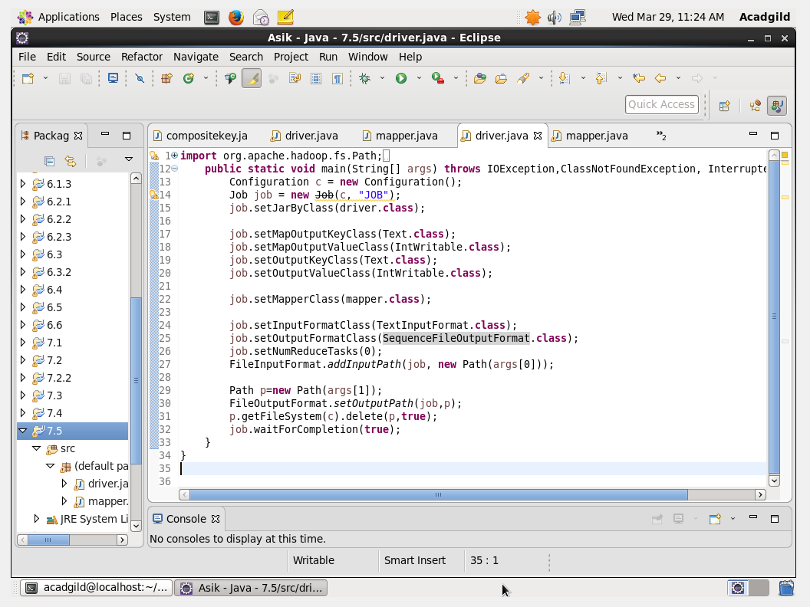

Mapper Class:

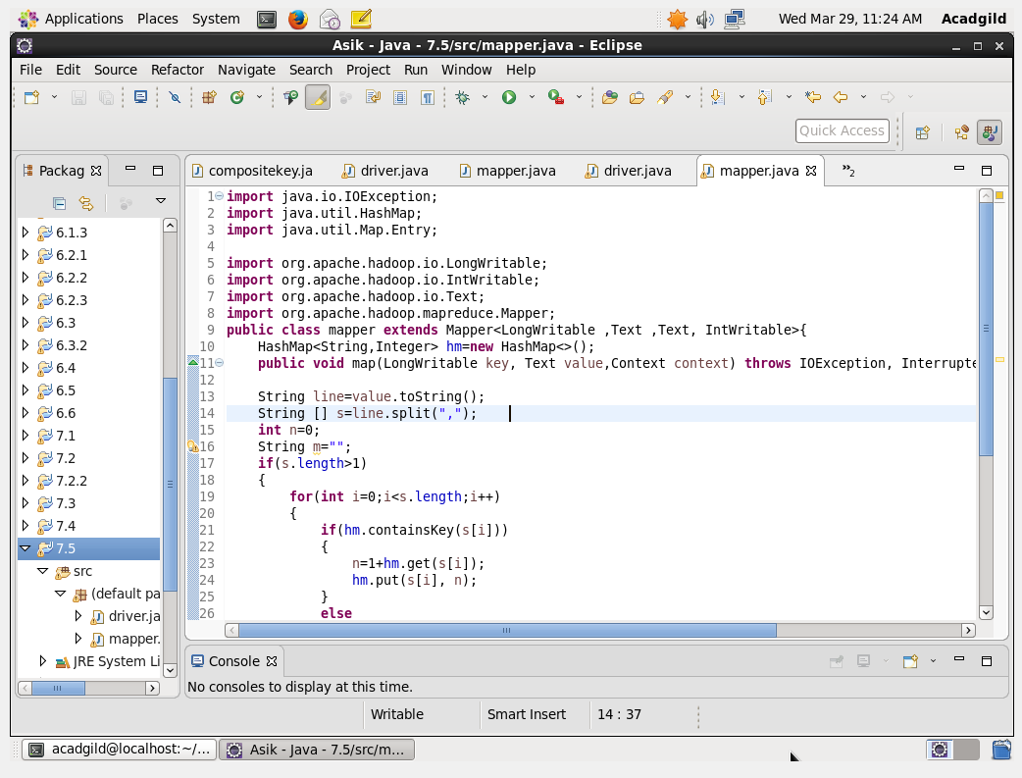

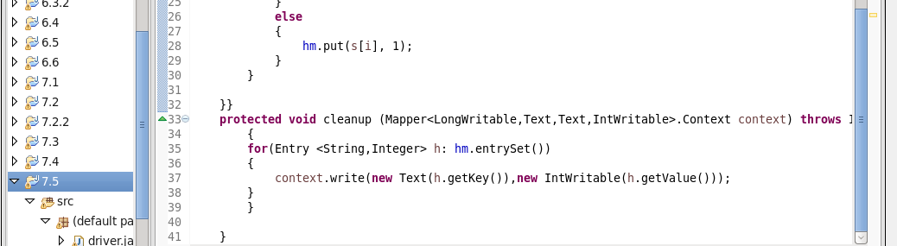

Executing the Jar File:

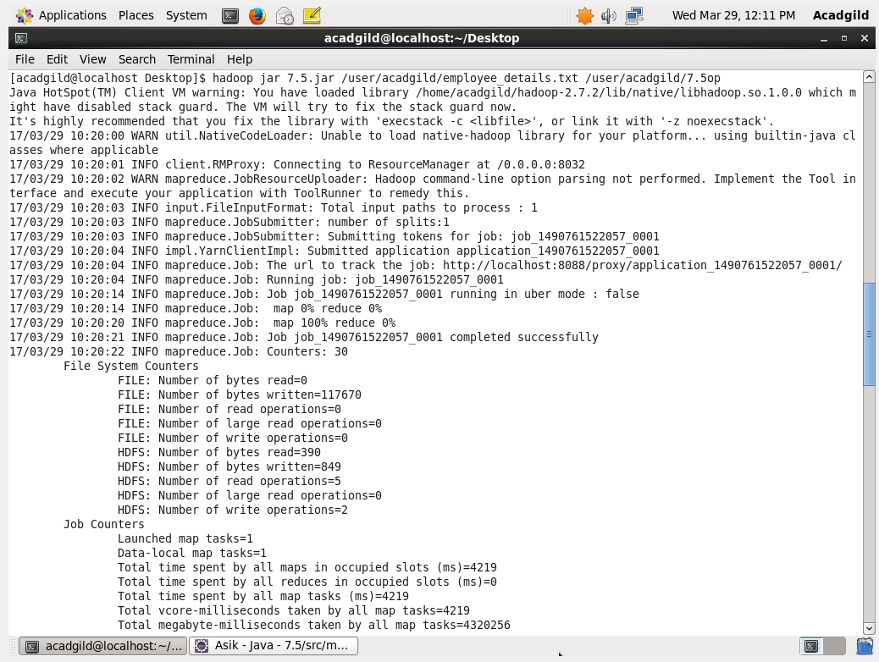

Output:

